SIMATS ENGINEERING
ASSESSMENT TOOL 1 - Low (Pseudo-code Writing)
COURSE CODE: CSA09 COURSE NAME: Programming in Java
COURSE OUTCOME COVERED
CO1: Apply object-oriented programming principles such as classes, objects, encapsulation, data hiding, inheritance, and polymorphism to design and implement entity manipulations (BL3,BL4)
QUESTIONS: 10 Total Marks: 100
ANNEXURE A PSEUDO-CODE WRITING
Code of Conduct:
I MONIKA G -192421158 (Name / Reg No) certify that this submission is my original work and that I have adhered to the guidelines specified for this assessment. I understand that any violation of academic integrity rules will result in disciplinary action.
Signature of the student:Monika G

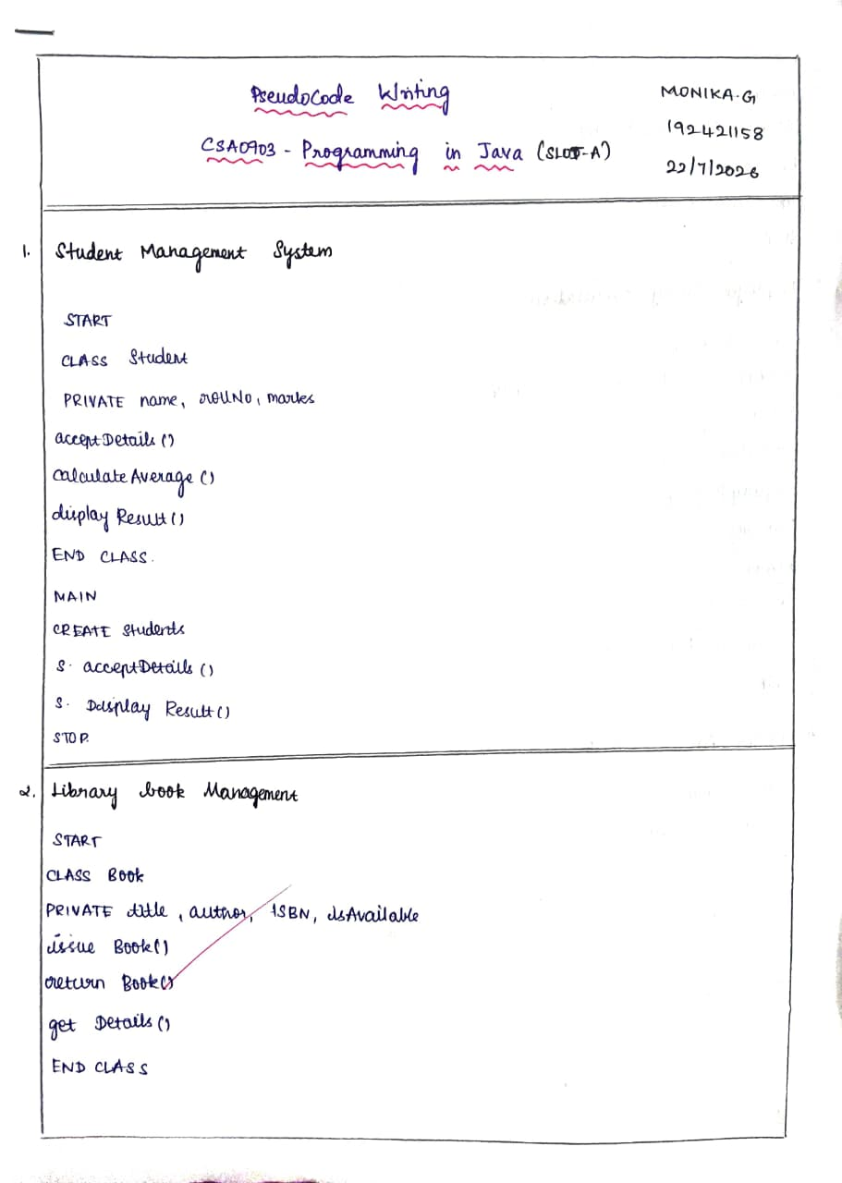
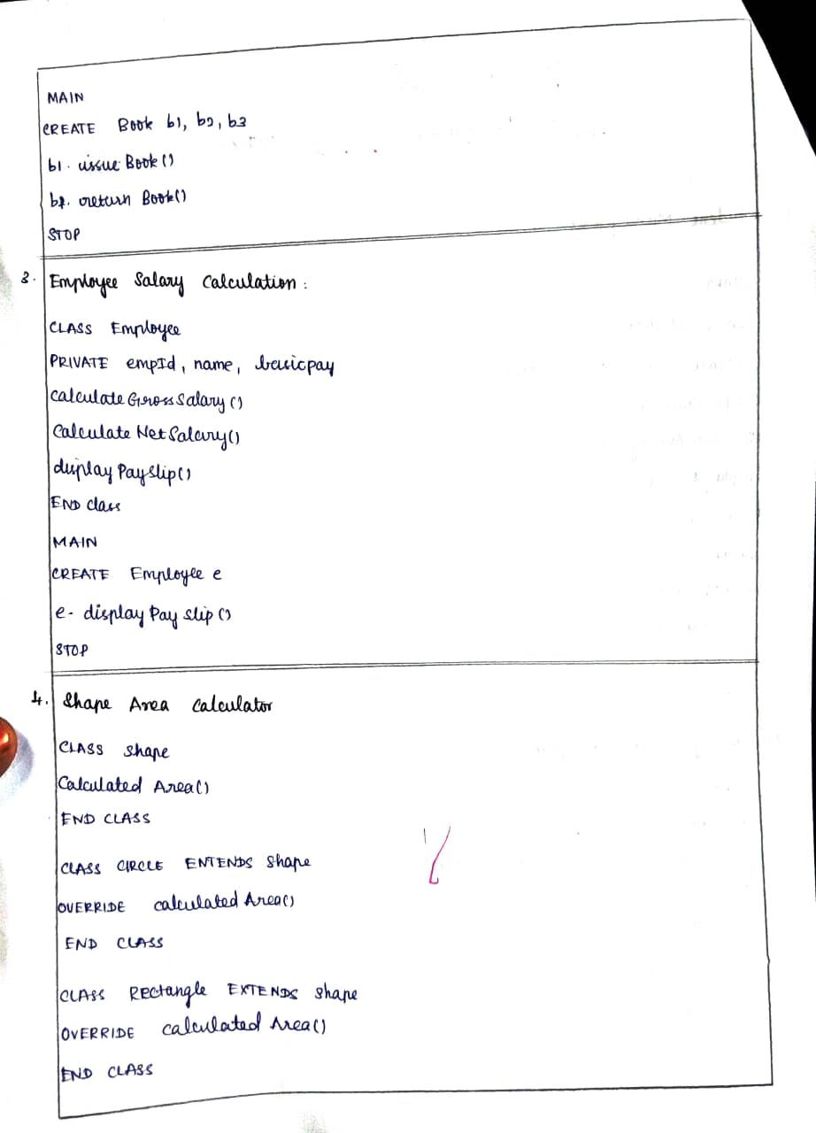
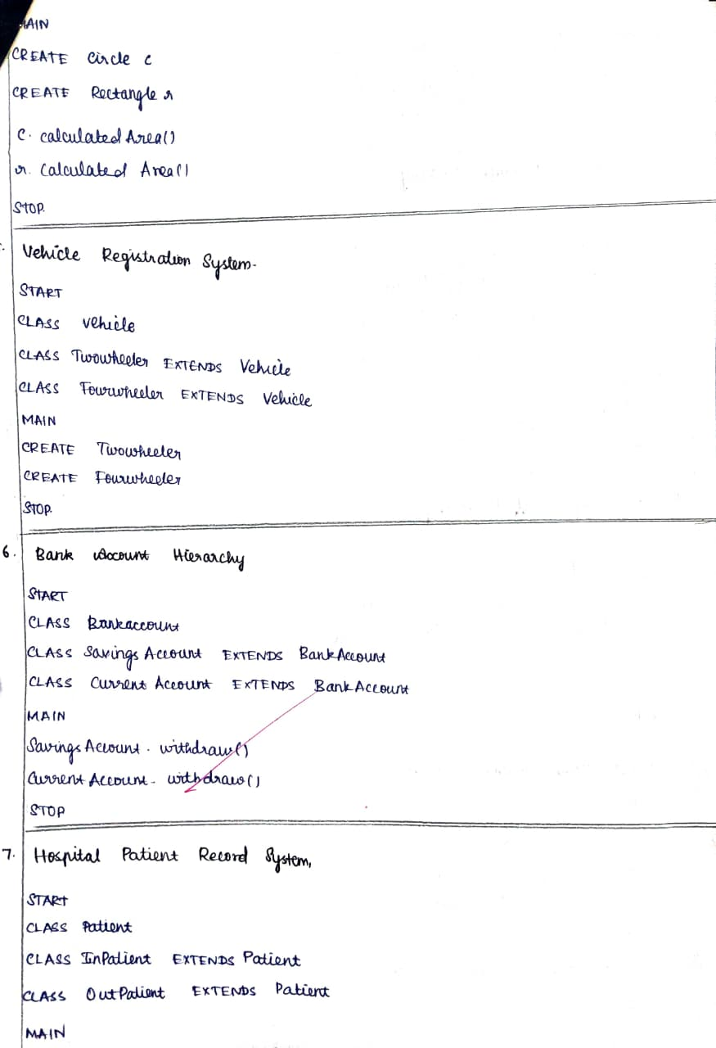
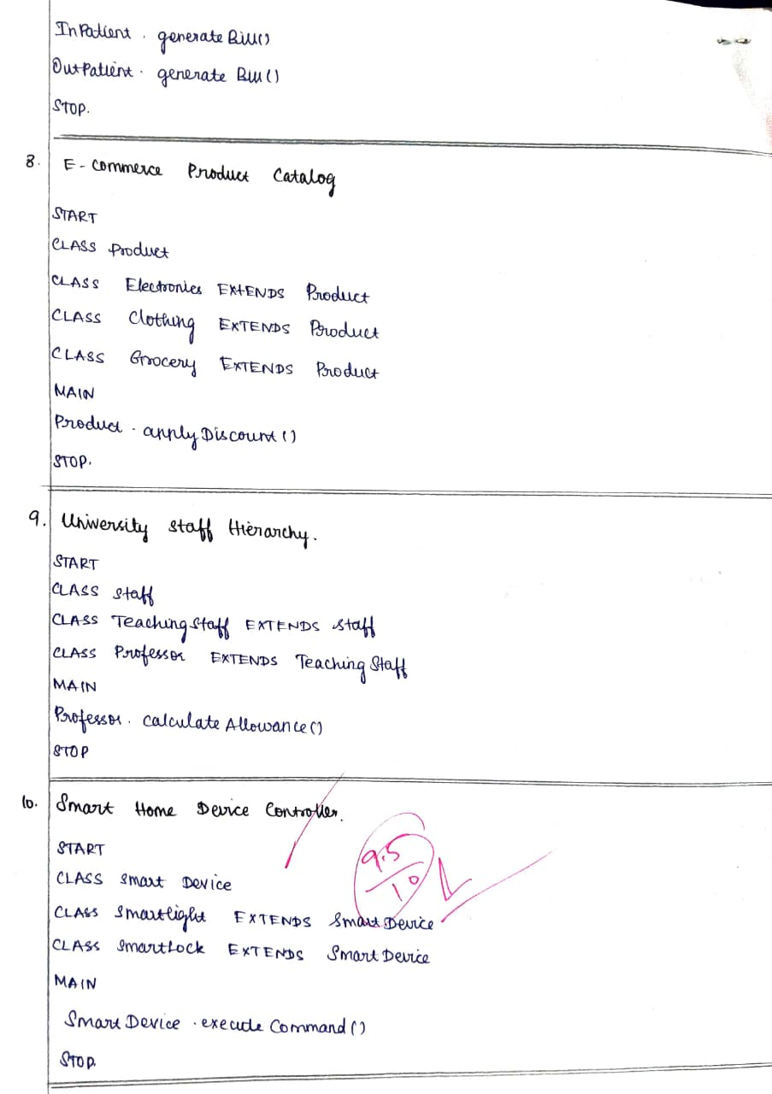
RUBRICS FOR CALCULATION:
Criteria | Weightage | Level 4 –  Exemplary | Level 3 –  Proficient | Level 2 –  Developing | Level 1 –  Beginning
Problem Understanding | 20% | Identifies all inputs, outputs, constraints accurately | Minor missing elements | Partial understanding | Incorrect interpretation
Algorithm Design | 30% | Complete, correct, and logically sound solution | Minor logical gaps | Partially correct logic | Incorrect approach
Use of Control  Structures | 20% | Efficient and appropriate use of loops, conditions, functions/modules | Minor inefficiencies | Limited or basic usage | Incorrect or missing constructs
Pseudocode  Structure | 10% | Well-structured, clear, consistent  format, easy to follow | Mostly clear with minor issues | Difficult to follow in parts | Poorly structured and unclear
Completeness | 20% | Handles all cases; optimized approach | Handles most cases;  reasonable efficiency | Handles basic cases only | Incomplete or inefficient

